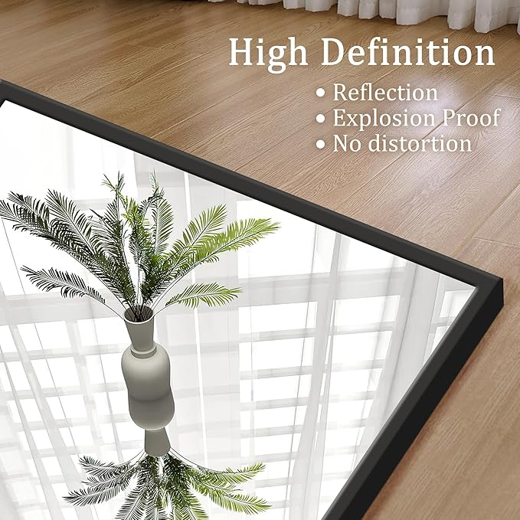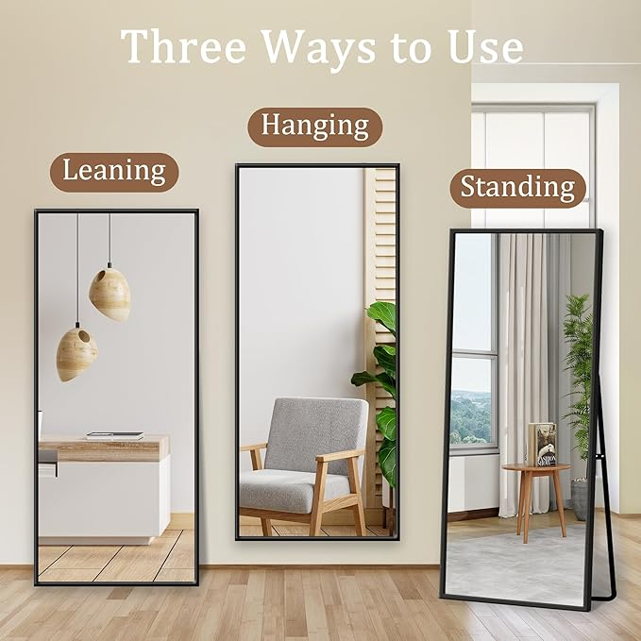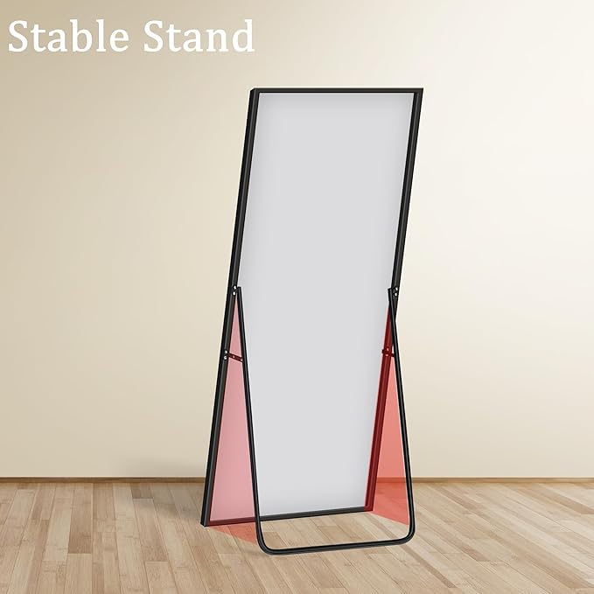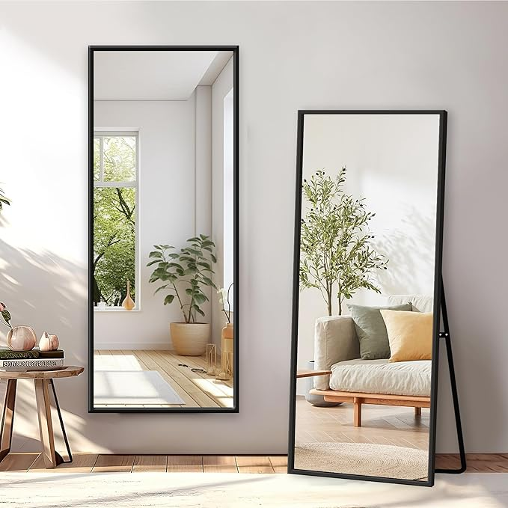

Full Length Mirror with Stand - 56" x 19" Aluminum Alloy Frame Full Body Mirror, Standing Hanging or Leaning Wall Floor Mirror for Bedroom Living Room Dressing Room, Black

**PRODUCT DESCRIPTION:**

|  |  |
| --- | --- |
| Brand | GlasFlength |
| Room Type | Cloakroom, Entryway, Dress Room, Bedroom, Living Room |
| Shape | Rectangular |
| Product Dimensions | 56"L x 19"W |
| Frame Material | Aluminum |

**About this item**

* Full-Length Mirror: At 56" x 19", this mirror offers a full-body view, making it easy to check your outfit from head to toe. Its large size ensures you won't miss a single detail and helps brighten up your room
* High-Quality Reflection: This full-length mirror is crafted from high-definition glass, delivering a clear and accurate reflection. The premium materials used in its construction ensure it stays distortion-free, providing a crystal-clear image
* Durable Aluminum Alloy Frame: Built with a high-quality aluminum alloy frame, this full-body mirror offers outstanding durability and stability. The lightweight yet sturdy material makes it easy to handle and install, while providing long-lasting support
* Versatile Usage: Ideal for a variety of spaces, this full-body mirror can be wall-mounted or used as a standing floor mirror. Perfect for bedrooms, living rooms, entryways, or dressing areas, it effortlessly complements any home decor style
* Easy Installation: Includes all the necessary hardware for both wall mounting and freestanding use. The installation process is simple, letting you quickly and securely set up the full-body mirror in your preferred spot